
Search: Some Effective Techniques for Naive Bayes Text Classification

Search: Ontology-Based Naive Bayes Short Text Classification Method for a Small Dataset
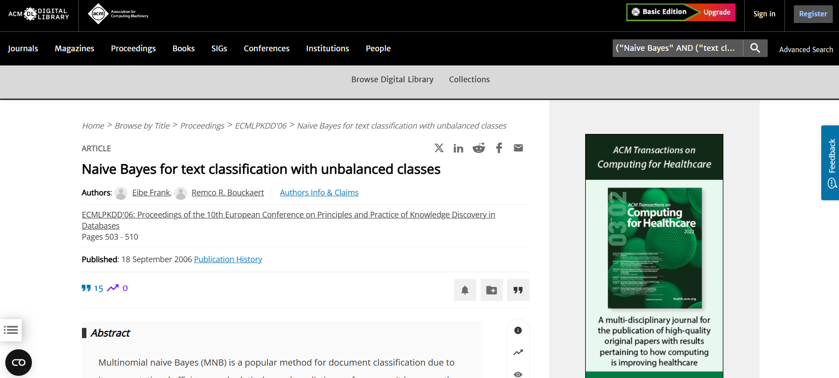
Search: Naive Bayes for text classification with unbalanced classes
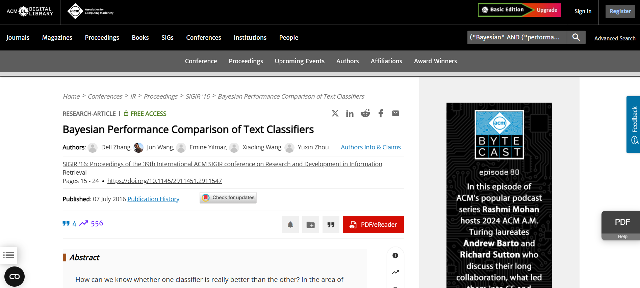
Search: Bayesian Performance Comparison of Text Classifiers
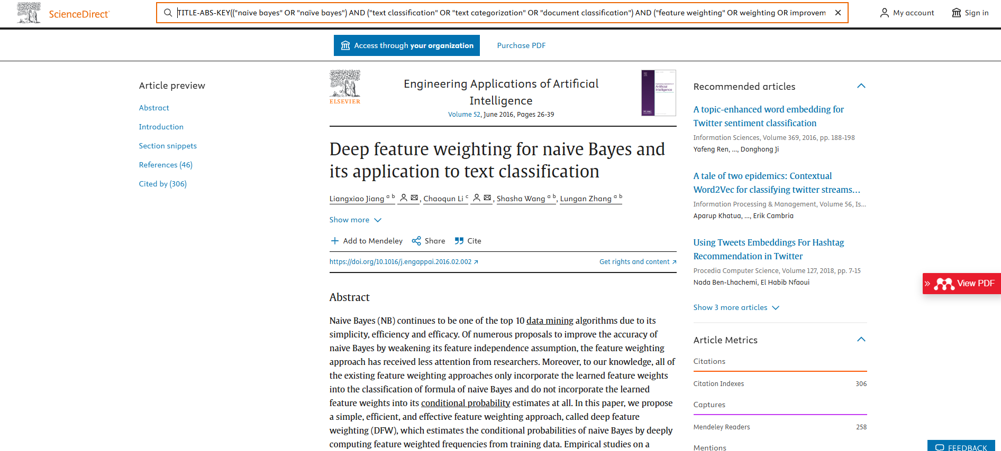
Search: Deep feature weighting for naive Bayes and its application to text classification

